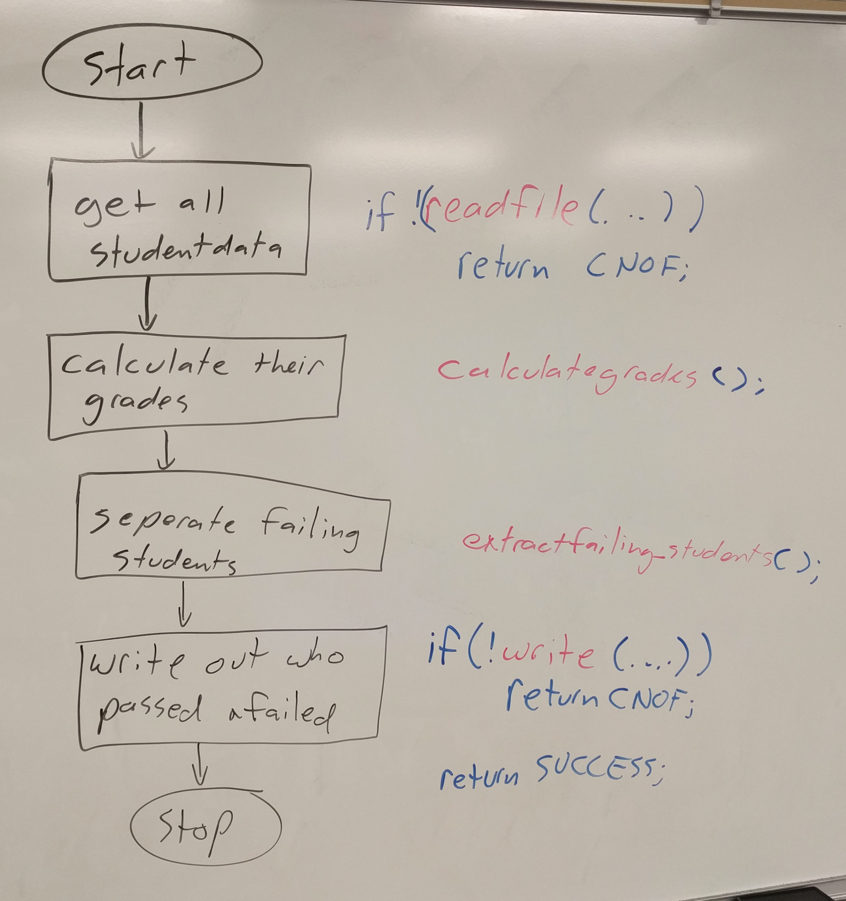

Utility projects follow this pattern
open and read file
process contents
write output

Vector Student Grades
Create projects
add a source folder (not a regular folder) ensures compilation

includes
constants.h
utilities.h
utilities
utilities.cpp
have 4_vector_list.cpp in regular src folder

have TestData.txt already there

do includes

then pop in source (utilities.cpp and 4_vector_list.cpp)
make sure your declaration agrees with definition (ie if & in h also in cpp)

//main see //TODO
//practice some sorting
sortArray(NAME);

//why might this one be especially useful?
sortArray(FINAL_GRADE);

//utilities.h
//sorts studentdata based on SORT_TYPE
enum SORT_TYPE{NAME,FINAL_GRADE};
bool sortArray(SORT_TYPE st);

//utilities.cpp
bool comp_name(const studentData &s1, const studentData &s2){
return s1.name<s2.name;
}
//any advantage to sorting high to low verses low to high?
bool comp_classgrade(const studentData &s1, const studentData &s2){
return s1.classgrade>s2.classgrade;
}
bool sortArray(SORT_TYPE st) {
switch (st){
case NAME:
std::sort(allstudentData.begin(), allstudentData.end(), comp_name );
break;
case FINAL_GRADE:
std::sort(allstudentData.begin(), allstudentData.end(), comp_classgrade);
break;
default:
//raise an error here
return false;
}

return true;
}

#include "../includes/constants.h"
#include "../includes/utilities.h"
using namespace std;

int process_Data(const std::string &infile, const std::string &Passfile, const std::string &Failfile) {
ifstream myInFile;

//open file
myInFile.open(infile.c_str());
if (!myInFile.is_open())
return COULD_NOT_OPEN_FILE;

//read file into vector, calculate final grade
if (!readFileIntoVector(myInFile))
return COULD_NOT_READ_FILE_INTO_VECTOR;

//close file
if (myInFile.is_open())
myInFile.close();

//calculate final grade
calculateFinalGrade();

//practice some sorting
sortArray(NAME);

//why might this one be especially useful?
sortArray(FINAL_GRADE);

//strip out failing students and add to fail.txt
extractFailingStudents();

//save failing students to other file
if (!writeDataToFile(PASS,Passfile))
return COULD_NOT_WRITE_VECTOR_TO_FILE;

if (!writeDataToFile(FAIL,Failfile))
return COULD_NOT_WRITE_VECTOR_TO_FILE;

return SUCCESS;
}

/*
* utilities.h
*
* Created on: Sep 17, 2013
* Author: lynn
*/

#ifndef UTILITIES_H_
#define UTILITIES_H_

#include <string>
#include "../includes/constants.h"

const double UNINITIALIZED = -1.0;
struct studentData{
std::string name;
double midterm,final;
double classgrade;
void clear(){name.clear();midterm=final=classgrade=UNINITIALIZED;}
};

enum ranking {PASS,FAIL};
enum SORT_TYPE{NAME,FINAL_GRADE};

bool readFileIntoVector(std::ifstream &file, char char_to_search_for=CHAR_TO_SEARCH_FOR);
void calculateFinalGrade();
void extractFailingStudents(double failgrade = FAILGRADE);

bool writeDataToFile(ranking r, const std::string &filename);

//sorts studentdata based on SORT_TYPE
bool sortArray(SORT_TYPE st);

//if myString does not contain a string rep of number returns o
//if int not large enough has undefined behaviour, very fragile
int stringToInt(const char *myString);
std::string DoubleToString ( double Number );

#endif /* UTILITIES_H_ */

int main() {
string infile = ALL_FILE;
string Passfile = PASS_FILE;
string Failfile = FAIL_FILE;

return process_Data(infile,Passfile, Failfile);
}

//ALTERNATIVE- pass the files as arguments
//const int FAIL_WRONG_NUMBER_ARGS = -5;
//const int EXPECTED_NUMBER_ARGUMENTS =4;
//const string WRONG_NUMB_ARGS = "This program expects 3 arguments, infile passfile failfile";

//int main( int argc, char *argv[] ) {
// //argc = how many arguments passed in (including this program)
// //char *argv[] char array of those arguments
//
// //expect progname infile passfile failfile //program and 3 arguments, argc=4
// if( argc != EXPECTED_NUMBER_ARGUMENTS ) {
// cout<< WRONG_NUMB_ARGS <<endl;
// return FAIL_WRONG_NUMBER_ARGS;
// }
// string infile = argv[1];
// string Passfile = argv[2];
// string Failfile = argv[3];
//
// return process_Data(infile,Passfile, Failfile);
//}

